**Routing**

All you need to do to implement the routing in Next.js is create a folder corresponding to the desired route within the app folder.

The name of the folder will serve as the route name.

In react Routing looks like this:

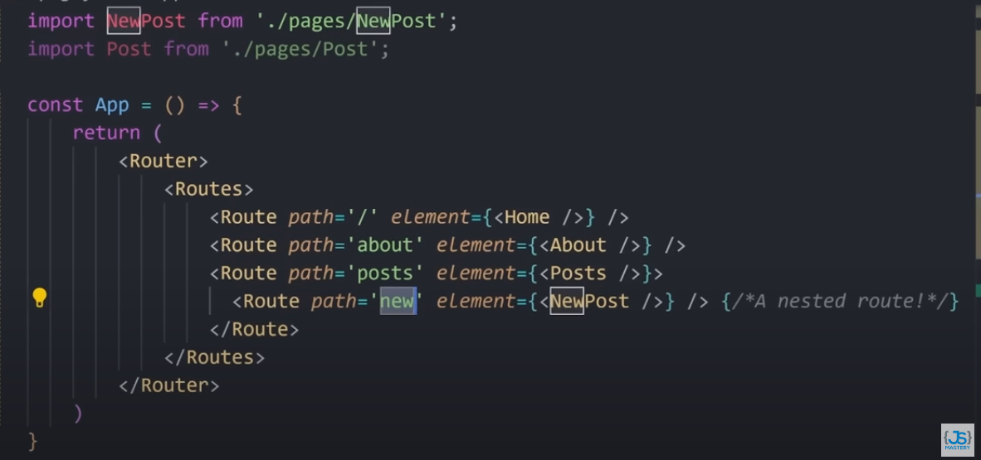

Here,   
*/posts/new*

Is nested routing.

Route in Next.js look like this:

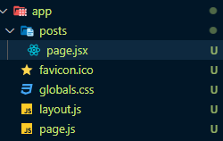

*/posts*

The same nested route of post in Next.js look like this:-

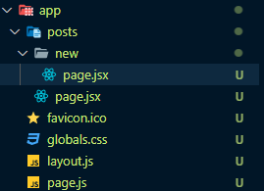

*/posts/new*

**Dynamic Routing**: Dynamic routing is like having a flexible system for creating website pages based on different variables or data.

Dynamic routing in React:-

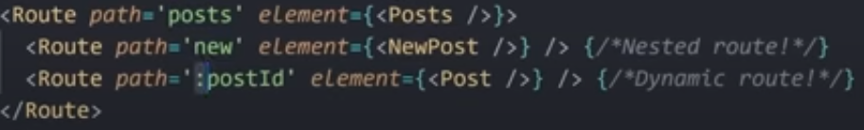

In Next.js it look like this:-

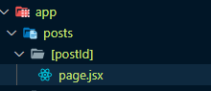

Under page.jsx file we’ll have access to {postId} data.